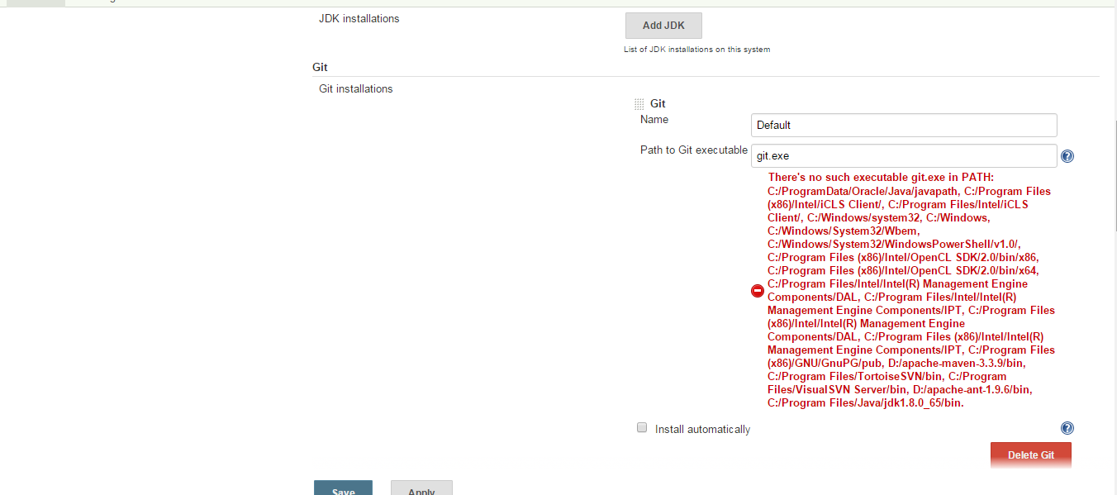
On Jenkins, add link to Git executable

After installing GitHub Desktop, Git executable's location is C:\Users\minhql.rt\AppData\Local\GitHub\PortableGit_c7e0cbde92ba565cb218a521411d0e854079a28c\cmd\git.exe

Enter Git url https://github.com/minhqlrt/SimpleSite.git

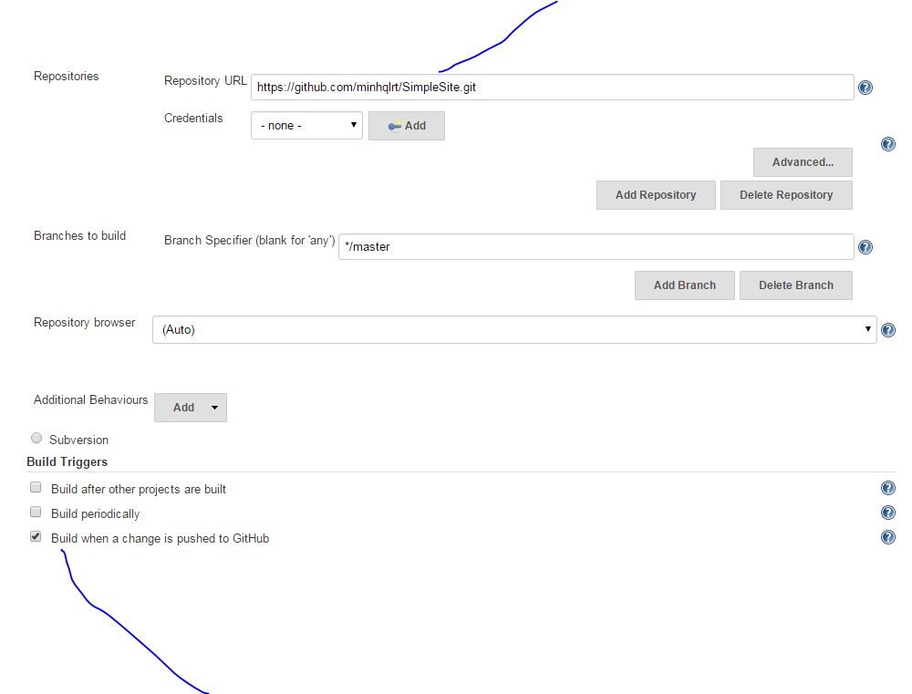

Trigger a build when a change is pushed to GitHub
This feature enables builds after post-receive hooks in your GitHub repositories. This trigger only kicks git-plugin internal polling algo for every incoming event against matched repo.
To be able to use this feature:

Add GitHub hook

To add GitHub hook, navigate to jenkins config, git section, github plugin configuration. Chọn credentials (navigate to Github website to create personal access token), click add secret text, paste personal access token to secret field. Click add then select this credential

You’re pretty close to being done. The final step is to head over to GitHub and adjust the settings for the project by creating a webhook for your Jenkins server. Select the repo you’re interested in and click Settings. If you aren’t an admin of the repo you will not be able to modify the settings, so talk to an owner to either finish this step for you or have them grant you admin to make the change yourself.
The GitHub steps are pretty straight forward. Open the “Webhooks & Services” tab -> choose “Configure Services” -> find the Jenkins (GitHub plugin option) and fill it in with a similar URL to the following:
- http://<Name of Jenkins server>:8080/github-webhook/
Remember that your Jenkins server's ip address must be accessible from internet for GitHub to see it.

.And, VERY IMPORTANT, since you are installing your jenkins server in your localhost, please be aware that you shouldn't fill in above Jenkins hook url like http://localhost:8080/github-webhook/because Github is not able to recognize localhost or 127.0.0.1 or 192.168.*.*.
Either you should use an externally accessible DNS name or an IP address, which can be recognized by Github.

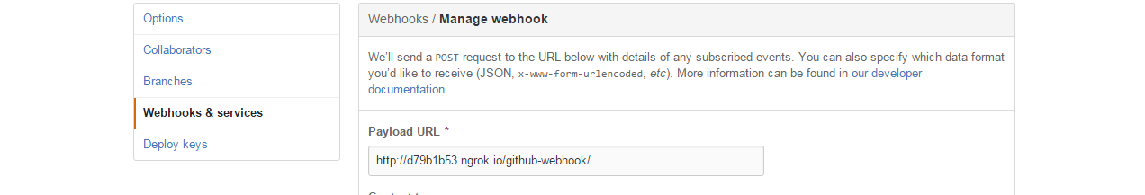
http://d79b1b53.ngrok.io/github-webhook/
The reason that we don't add port to url is: we already add port when openning ngrok: ngrok.exe http 9090

Dùng ngrok để github access jenkins
https://developer.github.com/webhooks/configuring/

To use custom subdomain. Login to ngrok and follow instruction https://dashboard.ngrok.com/

To add git command to windows command line, add C:\Users\minhql.rt\AppData\Local\GitHub\PortableGit_c7e0cbde92ba565cb218a521411d0e854079a28c\cmd to environment variables

